Skip Counting

Short Chain Skip-Counting

Direct Aim:
- To give the child another way of counting.

Indirect Aim:
- Preparation for multiplication

MATERIALS:
- A short chain (or the bead bars that are equivalent to the square of that number, e.g. 3 three-bars, 4 four-bars, etc.)
- The bead square for that chain
- DIY bead-bar alternative: printable bead bars (get them here)
- The arrows for that chain (arrows can be printed here)

PRESENTATION:
- Invite the child to choose any number.
- Take the short chain of that number, the arrows, and the square.
- Lay out the chain and fold it like a square.
- Superimpose the square on it and then stretch the chain out.
- Take out the arrows and order them.
- Count each number in the first bead bar and place an arrow immediately after counting it.
- For the next bead bars, count to the end of the bead bar and find the corresponding arrow for the last number on that bead bar.
- Put the square of the number at the end.
- Take off the first four arrows and repeat, this time skip counting forward and backward.
- After the child repeats the work, you can invite him to then count backwards and forwards.

Follow-up activity: Self-assessment
- Invite the child to turn over the arrows so he can’t see the numbers; he then has to skip count and check his work by turning each arrow over after he says the number.

Extended Skip-Counting

Direct Aims:
- To continue to become familiar with skip counting
- Continual linear counting
- Experience sensorially the difference between the cube and the square

Indirect Aims:
- A preparation for multiplication
- Understanding powers of numbers
- Understanding the concept of multiples

MATERIALS:
- Long chain, corresponding cube, corresponding squares, arrows
- Homeschool alternative: As many bead-bars of one number as the cube of that number (e.g. 16 four-bars, 25 five-bars)

PRESENTATION: The Thousand Chain (Optional)
- Lay out the long chain (or chain of bead-bars) folded in the same formation it had while hanging, so it resembles the squares.
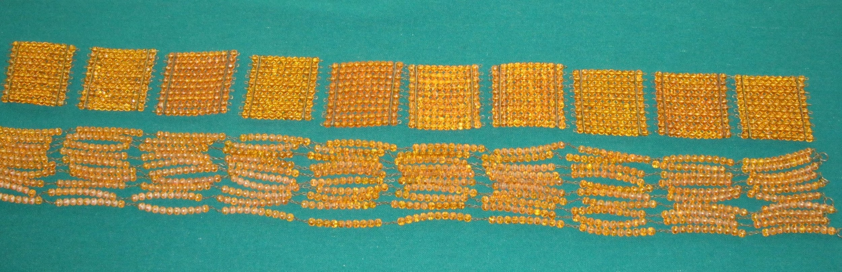
- Put the squares on top of the chain.
- Stack the squares to see if they make a cube, and compare the two.
- Stretch out the chain and lay out the arrows on a tray.
- Start counting and labeling, like with the short chain.
- Place the square when you get to the first large arrow.
- When the child is done, show him how to place all the squares together to make a cube.
- Point out that there is the same number of beads in the cube that there are on the chain.
- Take off the first set of labels and invite the child to skip count forward and backward.

Following Exercises:
- The same games as the short chain.
- Lay out the long and short chain, as well as the bar of a particular number to compare the three. Place the square at the end of the short one and the cube at the end of the long one.
- Compare all the short chains.
- Stack the squares of each chain in a pyramid and then match them to the chains.
- Build geometric shapes/polygons with the short chains.
- Compare all the long chains in a pipe organ formation (laid out one next to the other as they would look while hanging). Invite the child to discuss what they observe.

